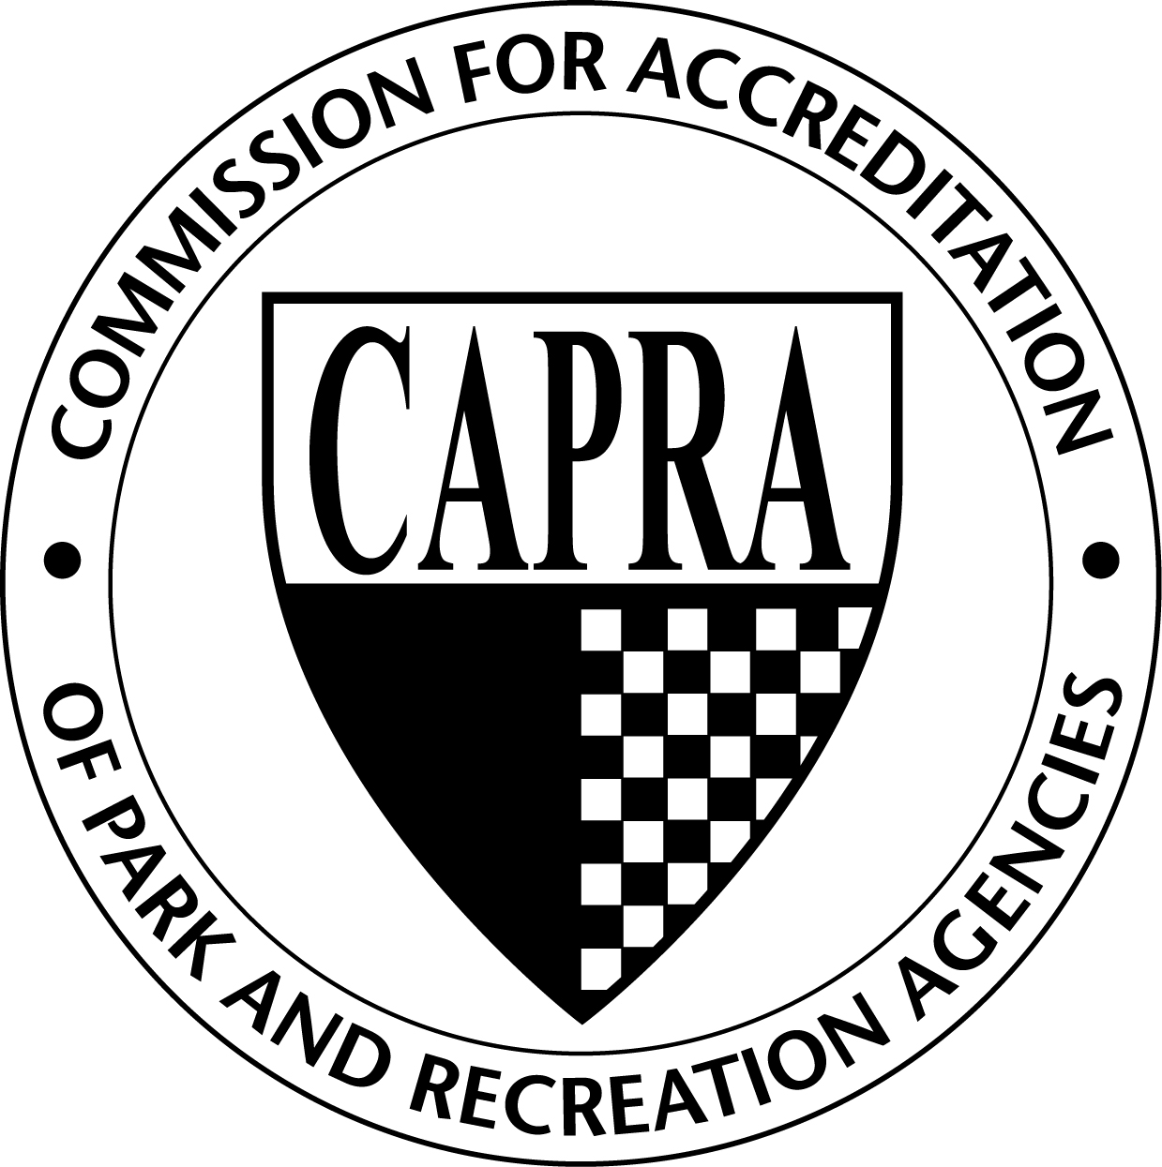
Documentation Needed for Accreditation

Section I----Agency Role and Responsibility
Standard | Documentation Needed for Compliance | Status of completion
1.1 Source of Authority | Resolution establishing department, enabling act by the state, City Charter referencing the authority of the department.
- Public authority/  policy body | Copy of organizational chart with narrative description; show relationship to city mayor, council, and departments.
1.1.2 Citizen advisory boards/committees | Provide list of boards/committees with membership, functions and duties, terms of office, frequency of meetings.
1.13 Responsibilities of Approving Authority, Chief Administrator, and Staff | Provide the established guidelines outlining the delineation of responsibilities for approving authority, chief administrator, and staff.
1.2 Jurisdiction | Need to provide a map showing location of facilities
1.3 Mission | Need to provide a copy of department’s mission statement- show when it was last reviewed.
1.3.1 Agency Goals and Objectives | Provide a copy of goals and objectives for each organizational component, with evidence of annual review and how it has been distributed.
1.3.2 Personnel Involvement | Provide examples of how input is obtained (e.g., memos, meetings, electronic communication, etc) regarding the development of goals and objectives within the department.
1.4 Process for Developing and Implementing Policies, Rules and Regulations, and Operational Procedures. | Provide documentation establishing how policies, rules and regulations, and operational procedures are developed and implemented. Need to show distinction between them.
1.4.1 Policy Manual | Provide copy of department’s policy manual with cover letter indicating how it is distributed to staff and the latest review by the approving authority and administrators.
1.5 Agency Relationships | Provide illustrations of cooperative efforts, including Memoranda of Agreement and Memoranda of Understanding with organizations and agencies you interact with. Show list of staff with liaison responsibilities.
1.5.1 Operational Coordination and Cooperative Agreements. | Show copies of any agreements and policies between other agencies, city/county agencies, schools and other public and private agencies

Section II--- Planning
Standard | Documentation Necessary for Compliance | Status of Completion
2.1 Overall Planning Function within Agency | Provide the responsibilities and functions of the planning entity. Provide resume of training and experience for staff and/or consultants who have planning capabilities.
2.2 Involvement in Local Planning | Define the role, personnel and documentation of involvement (i.e. minutes, agenda, cooperative agreements in local planning efforts within the community, not just in recreation planning issues.
2.3 Planning with Regional, State, Federal and Non-government Agencies | Define the role of agency personnel and documentation of involvement (minutes, agendas, cooperative agreements) in state federal and non-governmental agencies planning.
2.4 Comprehensive Plan | Provide the current Plan, with date of official approval; describe linkage to the Agency's capital improvement budget and a phased development.
2.4.1 Trends Analysis | Provide documentation on how trends analysis is done by the agency.
2.4.2 Community Assessment | Provide the latest community assessment and an indication of its use in park and recreation Agency planning
2.4.3 Community Inventory | Provide the inventory of programs and services and the physical resources of the community, demonstrating how the agency utilizes this information in the planning process. This includes all of the providers in the jurisdiction and not just those provided by the agency.
2.4.4 Needs Index | A needs index for determining priorities for development of services within the community should be established within the comprehensive plan.
2.5 Feasibility Studies | Feasibility studies should include market analysis, cost benefit analysis, site analysis, and external impact analysis for proposed facility development.
2.6 Strategic Plan | Provide the agency's strategic plan, date of approval by approving authority and indicate progress being made in implementing the plan.
2.7 Site Plans | Provide a representative sampling of the agency’s areas and facilities site plans.
2.8 Historical, Cultural and Natural Resource Management Plan | Include an inventory of historical, cultural and natural resources and recommendations for how these are managed. These resources may be addressed as part of the agency’s comprehensive plan.
2.9 Community Involvement | Describe how the interests representing the diversity of the community were involved in community planning efforts for recreation needs.

Section III—Organization and Administration
Standard | Documentation Necessary for Compliance | Status of Completion
3.1 Organizational Structure | Provide a copy of the department’s organizational chart that shows interrelationship with all components of the unit.
3.1.1 Statement of Purpose for Each Organizational Component | The agency should have an established purpose statement for each organizational component that is available to all employees
3.2 Administrative Policies and Procedures | Provide access to the administrative policies and procedures and demonstrate how this information is made available to personnel.
3.2.1 Administrative Offices | Provide documentation that describes the types of office space and administrative equipment used by the agency.
3.2.2 Support Services | A list of clerical and maintenance personnel should be provided, along with a listing of computer, telecommunication tools, and other support equipment.
3.3 Communication System | A communication system shall be established to insure the accurate and timely transfer of information, both internal and external. Provide a matrix of how this is accomplished.
3.4 Coordinated Process of Public Information, Community Relations, and Marketing | Provide information on an established process regarding the integrated role of public information, community relations, and marketing functions of the agency including periodic reporting and evaluation.
3.4.1 Public Information Statement | Provide a written statement that states the Agency is committed to informing the community and the news media of events within the public domain that are handled by or involve the Agency and sets forth policies that govern what information should be released, when it should be released, and by whom it should be released.
3.4.1.1 Public Information and Community Relations Position Responsibility | Provide the position description which reflects responsibilities for public information and community relations.
3.4.2 Community Relations Plan | The Community Relations Plan focuses on identifying and addressing community needs of all segments of its service population. Provide copy of the plan.
3.4.3 Marketing Plan | The Agency should have an established marketing plan, based on market research that includes an annual evaluation.
3.4.3.1 Marketing Position Responsibility | Provide the position description which includes responsibility for marketing. This may be a specific job responsibility or part of the duties of an administrative staff person including the Director.
3.5 Management Information Systems | Describe and provide examples of use of the management information system, such as recent statistical and data summaries.
3.5.1 Application of Technology | Provide a list of systems currently in use by the agency and any evidence of research regarding future systems uses. This should include not only computer applications, but telecommunication, lighting/irrigation systems, etc.
3.6 Records Management Policy and Procedure | Provide a copy of policy and procedures for retaining records for the agency. This is usually found in the clerk’s office with the governing authority.
3.6.1 Records Disaster Mitigation and Recovery | Provide the Records Disaster Mitigation and Recovery Plan and procedures. Should include information on storage of records as well.

Section IV--- Human Resources
Standards | Documentation Necessary for Compliance | Status of Completion
4.1. Personnel policies and procedures manual | Provide policies which govern the administration of personnel procedures for both professional and nonprofessional employees that are reviewed annually. Must show how it is shared with the staff.
4.1.1 Code of conduct (ethics) | Policy needs to be provided that shows appropriate actions and activities by staff to be an ethical and professional organization.
4.1.2 Recruitment process | Provide a policy on recruitment and selection of employees for employment.
4.1.3 Equal employment opportunity and workforce diversity | Provide a copy of the written equal opportunity and workforce diversity policy and show evidence of implementation of the policy.
4.1.4 Selection process | Written procedures that describe all components of the selection process should be developed.
4.1.5 Background investigations | Procedures should include:  The verification of a candidate's qualifying credentials;  A review of a candidate's civil and criminal record;  Particular attention to drug and child/adult abuse record; and  Driving record for employees assigned to operate motor vehicles.
4.1.6 Employee benefits | Provide a copy of the employee benefits program.
4.1.7 Supervision | Provide the plan for a systematic process for supervising personnel.
4.1.8 Compensation | Provide a copy of the compensation plan that will show salaries and wages and pay scales for all employees and when it was last reviewed.
4.1.9 Performance evaluation | Provide a copy of procedures for conducting performance evaluations and representative completed performance evaluations without identifying personal information.
4.1.10 Promotion | There needs to be a statement on promotions within the agency and indicate how it has been communicated to employees.
4.1.11 Disciplinary action | Provide a written copy of the disciplinary action, the dated when approved, and how they are communicated to employees.
4.1.12 Appeals and grievances | Provide a copy of the grievance procedure and indicate how the procedures have been communicated to the employees.
4.1.13 Termination and end of employment | Provide copy of the dated and approved termination and end of employment policies and procedures, and indicate how they have been communicated to employees.
4.2 Staff Qualifications | List professional staff with the responsibilities and qualifications to carry out such responsibilities.
4.3 Job Analysis and Job Descriptions | Provide a copy of the dated and approved job analysis policy and evidence of job descriptions for all temporary, permanent and internship positions.
4.4 Chief Administrator | Provide name and professional qualifications of the current chief administrator; also provide copy of position description. Evidences of "professionally qualified" include: (1) Certified Park and Recreation Professional (CPRP); (2) degree in parks and recreation or related field; or (3) years professional experience in parks and recreation commensurate with the position qualifications; and (4) involvement in professional park and recreation organizations.
4.5 Physical examination | Provide a dated and approved copy of the physical examination written policy procedures and evidence of compliance.
4.5.1 Workforce Health and Wellness | There should be a program which enhances general health and physical fitness of employees. This can be done by the agency or by another agency within the city. Provide information on use by employees.
4.6 Orientation program | Provide a copy of current orientation program.
4.6.1 In-Service Training Function | Develop an in-service education program which is evaluated, updated, and reviewed annually. Provide outline of training provided.
4.6.2 Employee development | Develop a program of employee development based on needs of individual employees and future organizational needs. Employee development should be available for employees throughout the organization.
4.6.3 Succession Planning | Develop a plan to ensure the continued effective performance of the organization by making provisions for the development and replacement of key people over time.
4.6.4 Professional organizations | Provide a list of professional personnel, and the professional park and recreation organization(s) in which they are a member; indicate nature of participation.
4.7 Volunteer Management | Provide a comprehensive volunteer management manual of the agency that will encompass policies and procedures related to the management of volunteers.
4.7.1 Utilization of Volunteers | Develop a list of how volunteers are used to provide assistance with the department operations.
4.7.2 Recruitment, Selection, Orientation, Training and Retention of Volunteers | Provide description of recruitment, selection, orientation, training and retention procedures for volunteers. Also provide evidence of how background investigations are conducted on volunteers.
4.7.3 Supervision and Evaluation of Volunteers | Provide written description of the monitoring system, current practices for supervisory visits, in-service training, and evaluation process
4.7.4 Recognition of Volunteers | Outline how volunteers are recognized and rewarded for their time and commitment.
4.7.5 Liability Coverage for Volunteers | Provide documentation on how volunteers are covered within the agency.
4.8 Consultants and Contract Employees | Provide a dated and approved copy of agency policies and procedures regarding use of consultants and contract employees.

Section V--- Financial Management
Standard | Documentation Necessary for Compliance | Status of Completion
5.1 Fiscal Policy | Provide fiscal policies setting guidelines for management and control of revenues, expenditures, and investment of funds and the legal authority.
5.1.1 Fees and Charges | Provide a dated and approved copy of the policy on fees, charges and the current fee schedule.
5.1.2 Acceptance of Gifts and Donations | Provide a copy of a dated and approved written policy on accepting of gifts and donations.
5.1.3 Governmental Grants | Provide a summary of governmental grants received by the agency for the past five years, including identification of the following: project descriptions, grantor,  date awarded, grant amount, agency match requirements.
5.1.4 Private Corporate and Non-Profit Support | Provide a summary of private, corporate and non-profit grants and/or partnerships received by the agency for the past five years including identification of the  following: project descriptions, grantor/sponsor, date awarded, value of the contribution and applicable  recognition.
5.2 Fiscal Management Procedures | Provide information on "fiscal management function" that includes, at a minimum, annual budget development, supervision of internal expenditures and revenues and related controls. This can be provided in a procedure statement or from City Charter.
5.2.1 Authority and Responsibility for Financial Management | Provide documentation demonstrating clear delegation of the fiscal authority for the agency to the Director.
5.2.2 Purchasing Procedure | Provide written procedures for the requisition and purchase of agency  equipment, supplies and services.
5.2.2.1 Emergency Purchase Procedures | Provide policy statement on making emergency purchases quickly and efficiently.
5.3 Accounting System | Provide a description of the accounting system and how it integrates with the overall city accounting system.
5.3.1 Financial Status Reports | The Agency should have an accounting system that includes, at a minimum, provisions for  regular status reports showing:  - Initial appropriation for each account (or program);  - Balances at the commencement of the regularly defined period;  - Expenditures and encumbrances made during the period;  - Unencumbered balances; and  - Revenue status.
5.3.2 Position Authorization | Provide a copy of position authorization procedures and budgeted positions.
5.3.3 Fiscal Control and Monitoring | Provide written procedures used for collecting, safeguarding, and disbursing funds, to include, at a minimum:  - Maintenance of an allotment system, if any, or records of appropriations among organizational components;  - Preparation of financial statements;  - Conduct of internal audits; and  - Persons or positions authorized to accept or disburse funds.
5.3.4 Independent Audit | Provide a copy of recent independent audit and management letter, if provided; indicate response to recommendations.
5.4 Annual Budget | Provide a current and approved copy of the annual operating and capital improvements budgets.
5.4.1 Budget Development Participation | Provide information in how the heads of the agencies major organizational components are involved in the budget process.
5.4.2 Budget Recommendations | Provide recommendations that have been made by the agency and presented to the governing authority.
5.5 Budget control | Provide procedures for budget control within the agency, including allotment system, accounting system, frequent reporting of revenues and expenditures and continuous management review.
5.5.1Supplemental/emergency appropriations | Provide written procedures for requesting supplemental or emergency appropriations and fund transfers.
5.5.2 Inventory and fixed assets control | Provide current and approved policies and procedures for inventory and fixed asset control.

Section VI--- Programs and Services Management
Standards | Documentation Necessary for Compliance | Status of Completion
6.1 Recreation Programming Plan | Provide a copy of long-range and current-year recreation program plans and date of approval.
6.1.1 Programs/Services Determinants | The programs and services provided shall be based on:  conceptual foundations of play, recreation, and leisure; constituent needs; community opportunities; agency philosophy and goals; experiences desirable for clientele.  Provide documentation and examples that the five determinants have been used in planning for programs and services.
6.1.2 Participant Involvement | Describe the process for obtaining and utilizing participants' input and provide examples.
6.1.3 Self-Directed Programs and Services | Provide examples of how the agency provides self-directed recreation opportunities, including a list of such opportunities.
6.1.4 Leader Directed Programs and Services | Provide examples of how the agency provides leader-directed recreation opportunities, including a list of such opportunities.
6.1.5 Facilitated Programs and Services | Provide examples of how the agency provides facilitated recreation opportunities, including a list of such opportunities.
6.1.6 Fee-Based Programs and Services | Provide a listing of the fee-based programs and services within the agency.
6.1.7 Cooperative Programming | Provide description of cooperative programming with examples of Memoranda of Understanding (MOU), Memoranda of Agreement (MOA), partnering, or outsourcing.
6.2 Objective s | The agency shall define the program areas by the objectives. These can be defined by the program areas; such as; nature, dance, music, sports, fitness, special events etc. These can also be defined further into levels such as beginner, intermediate and advanced
6.3 Program Evaluation | Provide examples of completed program evaluations with analyses of how issues were addressed.
6.4 Outreach to Underserved Populations | Identify underserved populations (provide methodology and data used for this analysis), describe specific barriers within the community that limit participation and provide examples of outreach programs and services offered by the agency to meet the needs of this population.
6.5 Scope of Program Opportunities | Provide a matrix or listing of programs by fields, demonstrating clearly how the agency provides for opportunities for various proficiency levels, socio-economic levels, racial and ethnic backgrounds, ages, and genders
6.6 Selection of Program Content | Provide a list of program activities and describe how individual and cultural interests were considered when developing the programs.
6.7 Community Education for Leisure | Provide examples of the agency educates the community on the value, benefits, and impact of leisure services.
6.8 Program and Service Statistics | Provide examples of statistics collected for programs and how the agency utilizes the data.

Section VII--- Facility and Land Use Management
Standard | Documentation Necessary for Compliance | Status of Completion
7.1 Acquisition of Park and Recreation Lands | Provide policy and procedures for land acquisition and the citation of legal authority to acquire lands.
7.2 Development of Areas and Facilities | Provide policy on land and facility development.
7.3 Defense Against Encroachment | Provide the procedures regarding defense against encroachment. This may be found in local ordinances, design standards or by policy.
7.4 Disposal of Lands | Provide the disposal of park and recreation land procedures. This may be part of state law, local ordinance or policy past by governing authority.
7.5 Maintenance and Operations Management Plan | Provide the current maintenance and operations management plan.
7.5.1 Facility Legal Requirements | A regular review of legal requirements related to facilities, such as licenses, sanitary regulations, fire laws, and safety measures, and inspections of adherence thereto.
7.5.2 Preventive Maintenance Plan | Provide the preventative maintenance plan and examples of facility preventative programs with completed inspections and safety checks.
7.5.3 Recycling | Provide description of the recycling program for facilities and administrative offices.
7.6 Fleet Management Plan | Provide the fleet management plan and matrix listing inventory and maintenance schedules.
7.7 Agency-Owned Equipment and Property | Provide policy and procedures regarding agency-owned equipment and property.
7.8 Natural Resource Management and Environmental Stewardship | Policy and procedures are needed to address environmentally unique areas, wetlands, riverbanks, and woodlands valuable for erosion control, nature study, wildlife habitat, water supply reservoirs and water recharge areas.
7.9 Environmental Sustainability | Provide a policy that addresses energy conservation, environmentally preferable purchasing, water conservation/quality protection and sustainable design/construction of buildings and facilities.
7.10 Maintenance Personnel Assignment | Provide examples of how the agency assigns staff.
7.11 Capital Asset Depreciation and Replacement | Provide the capital asset depreciation and replacement schedule.

Section VIII--- Public Safety, Law Enforcement, Safety and Security
Standard | Documentation Necessary for Compliance | Status of Completion
8.1 Laws and Ordinances | Provide documentation of the prevailing laws, ordinances and codes that pertain specifically to areas and facilities under the jurisdiction of the agency including documentation of approval.
8.2 Authority to Enforce Laws and Ordinances by Law Enforcement Officers | Provide documentation that establishes the authority of Law Enforcement Officers to enforce laws and ordinances within the agency’s jurisdiction. Usually found in the Code of Ordinances.
8.3 Law Enforcement Officer Training | Provide examples that the current training program for Law Enforcement Officers having jurisdiction within the parks and recreation agency includes the full scope of responsibility and provides for ongoing training updates.
8.4 Public Safety and Law Enforcement Role of Agency Staff | Provide documentation that defines the role of agency staff in public safety and enforcement of laws, ordinances, rules and regulations. This means how is the agency keeping informed and sharing law enforcement issues with staff and public.
8.4.1 Staff Liaison to Law Enforcement Officers | Provide current documentation formalizing the liaison assignment(s) to agency staff with the law enforcement authority responsible for enforcement of laws and ordinances within the parks and recreation areas and facilities.
8.4.2 Public Safety and Law Enforcement In-Service Training for Agency Staff | Provide current documentation of in-service training for agency staff defining their role in public safety and law enforcement.
8.4.3 Handling of Disruptive Behavior | Provide procedures for agency staff for response to disruptive behavior at agency areas and facilities.
8.4.4 Traffic Control, Parking Plans, and Crowd Control | Provide evidence that illustrates the coordination of traffic control, parking plans and crowd control for activities and events hosted or facilitated by the agency.
8.4.5 Handling of Evidentiary Items | Provide the procedures defining the role and responsibility of agency staff in the discovery, preservation and handling of evidentiary items.
8.5 General Security Plan | Provide the agency’s general security plan with documentation illustrating that it is reviewed annually and updated to reflect current conditions.
8.6 Emergency Management Plan | Provide the applicable emergency management plan with the most recent date of approval. If, due to security concerns, the emergency management plan is not available for public review, acceptable evidence is the emergency management plan’s table of contents.
8.6.1 In-Service Training of Agency Staff of Security and Emergency Management | Provide documentation of in-service training programs on general security and emergency management, including a dated outline of the presentation topics and a roster of participants.

Section IX- Risk Management
Standard | Documentation Necessary for Compliance | Status of Completion
9.1 Risk Management Plan | Provide the current risk management plan with the most recent review date and approval by the proper authority
9.1.1 Statement of Policy | Provide the risk management policy including indication of approval by the proper authority.
9.1.2 Risk Management Operations Manual | Provide the risk management operations manual and demonstrate how employees of all levels are made aware of the aspects pertinent to their responsibilities.
9.1.2.1 Accident and Incident Reports | Provide the accident/incident form(s) and the procedures for documenting and analyzing accidents and incidents.
9.1.3 Personnel Involvement and Training | Demonstrate how personnel at all levels are included in the risk management function of the agency.
9.2 Risk Manager | Demonstrate the assignment of risk management responsibility to an individual authorized to carry out the policies established for risk management.

Section X – Evaluation and Research
Standard | Documentation Necessary for Compliance | Status of Completion
10.1 Evaluation Analysis | Describe the process for evaluation and cite examples for how this data has been used by the agency. This may be part of an overall evaluation plan or elements of a process that shows that evaluations are done and data is used to make improvements.
10.1.1 Position Responsibility for Evaluation | Provide the job descriptions of the staff person(s) responsible for the comprehensive evaluation analysis and/or the consultant contracts or service agreements.
10.2 Experimental and Demonstration Projects | Provide a report on an experimental or demonstration project for the last year and list projects for the last 5 years.
10.3 Personnel Training for the Evaluation of Programs, Services, Areas and Facilities | Provide examples of evaluation and research training opportunities completed by agency personnel, including syllabus or curriculum outline, training dates and participant list. Make sure that the training provided is for the evaluation process and not general training of staff.
10.4 Quality Assurance | Provide examples for monitoring and evaluating quality assurance within the agency. (Examples: customer comment cards, secret/mystery shopper surveys, verbal surveys of users, program evaluations, focus groups)

